we have the option, within ABAP, of referring to specific characters within a field. This is referred to as processing sub-fields, whereby we reference a specific character position within the field itself.

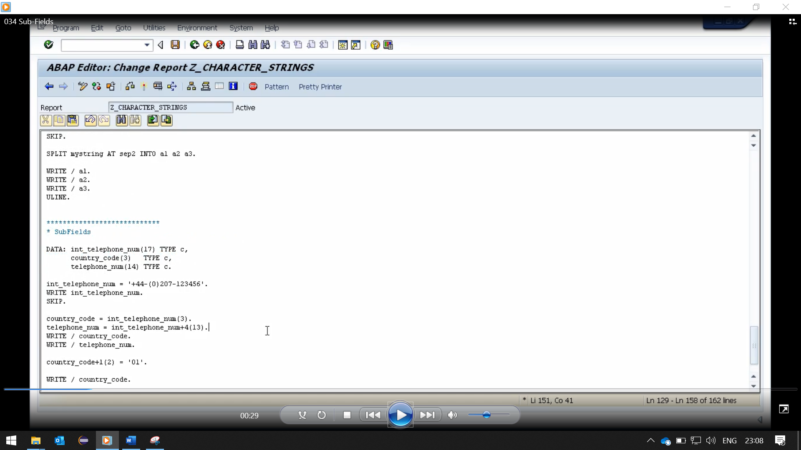

And the first line we have, I am assigning a character string to international telephone number, write in the results to the screen, followed by a blank line.

And then we come down to the actual sub-field processing itself. So, our first line of code shows that we are filling the country code field with the first three characters of the international telephone number field.

Let's have a look at our second line. In this example, we can see the field telephone number, is going to be filled with 13 characters of the international telephone number field starting after the fourth character.

So how we'd write this is telephone number equals international telephone number plus 4, which means start after the fourth character, open brackets 13 close brackets, which references 13 characters. Then we're going to move the output to the screen.

Then the last example we have Is instead of just moving specific characters of the international telephone number field, to telephone number. We're going to be updating the country code sub-fields with the literal 01.

So how we write this is, our country code field +1, which means stat after the first character and fill the next two characters. So, the country code field is only three characters in total anyway, so in effect, it's going to fill the last 2 characters of this field with the value of 01.

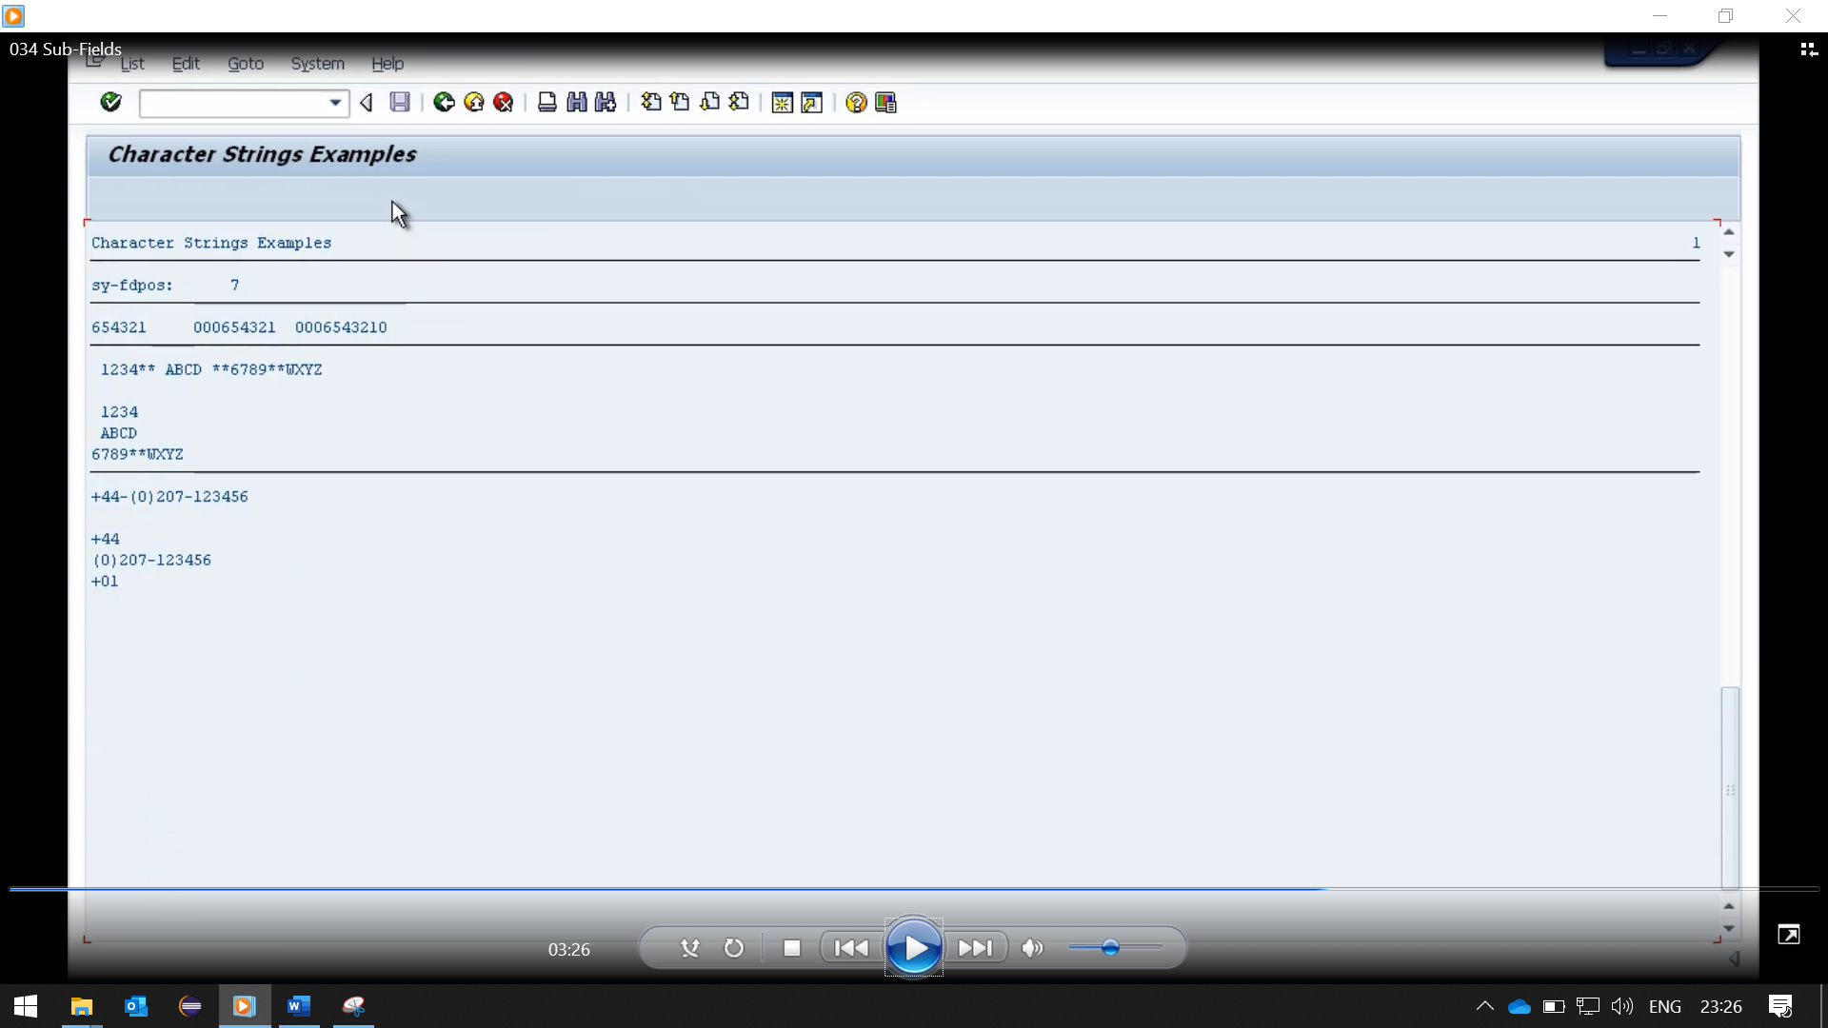

So first, we're outputting the full international telephone number to the screen. Then the next field, the country code field, we filled with the first three characters of the international telephone number field.

The next one, the actual telephone number, we reference 13 characters after the fourth character.

So, the fourth character was the Dutch sign, so we can see the next 13 characters starts with the open brackets and ends with the number 6.

In our last example it updated the country code field, but as a sub-field. So, it only updated the second and third character of the field.